Using Factorial Design to Identify Significant Factors for Water Beads Growth

Chloe Shin
SDS 4110: Experimental Design
December 16, 2025

I. Introduction and Motivation
Water beads are composed of superabsorbent polymers (SAPs), typically petroleum products, polyacrylate, and other related acrylic compounds. SAPs are known for their ability to absorb and retain exceptionally large quantities of water, expanding to more than 100 times their original volume. As the hydrophilic chains of SAPs attract water molecules and starts to unfold, osmosis occurs due to the difference in sodium concentration inside and outside the chain, driving additional water. The structure expands as it continues to take in water and turn into a gel-like substance. Originally developed for agricultural applications by maintaining soil moisture, their use has since broadened to products such as baby diapers, children’s toys, home décor items, and for flower arrangements. As water beads has become increasingly popular as children’s toys, numerous media sources and online communities have proposed methods for maximizing their growth, including recommendations to use warm, uncontaminated water and provide ample space and light. Even Orbeez, one of the most popular water beads brand, states on its website that “the purer the water, the larger the Orbeez will grow” (2020).
To evaluate the validity of these common claims, this experiment aims to identify whether the tree factors — (1) temperature, (2) type of water, and (3) type of solution—significantly affect water bead growth. A secondary objective is to determine which combination of these factors produces the maximum growth. This experiment implements 2 x 3 x 3 unreplicated, completely randomized full-factorial design to test up to three-way interactions.
II. Experimental Units and Variables
The experimental units in this study are individual water beads, with the observational units being the same beads measured after treatment. All beads were sourced from the same brand and batch, allowing the experiment to reasonably assume homogeneity across units. This study examined three fixed treatment factors: water type (tap vs. distilled), temperature (hot vs. room vs. cold), and solution type (none vs. salt vs. dish soap).
For the Temperature factor, the Cold condition was defined as water taken directly from the refrigerator, while the Hot condition was prepared by mixing 25mL of boiling water with 25mL of room temperature water. During the experiments, beads assigned to Cold and Hot conditions were stored in a refrigerator and a sealed Stanley tumbler, respectively, to maintain temperature.
For the Solution factor, at the Salt and Dish Soap levels, ½ teaspoon (~2.5 mL) of each solute was added to 50mL of water. The total water volume was held constant at 50mL across all treatment combinations. Each bad remained in its assigned solution for 3 hours.
Several un controlled or potential lurking variables were present. Because the lid remained closed for the Hot condition to conserve heat, beads in the Hot treatments received less light exposure than those in the Room and Cold conditions. Additional sources of variation include differences in the beads’ initial diameters and possible variation in solution concentration due to temperature.
The response variable for this study is the percentage growth rate of the water beads, calculated by comparing each water bead’s diameter (in millimeters) before and after the treatment. All measurements were obtained using a digital caliper to minimize human measurement errors.
III. Study Design
This experiment follows a 2 x 3 x 3 unreplicated, completely randomized full-factorial design, resulting in 18 unique treatment combinations. Each treatment combination was randomly assigned to one experimental unit, yielding a total of 18 individual runs. 18 water beads were randomly selected from a batch of approximately 30,000 beads, and then randomly assigned to each treatment combinations using R.
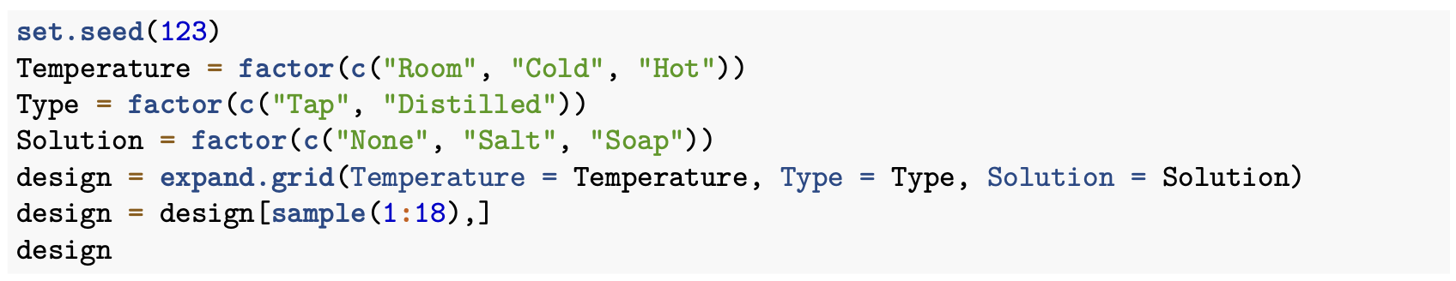
The linear model for the growth rate is:
$$Y_{ijkl}= μ+ α_{i}+β_{j}+γ_{k}+{{αβ}_{ij}+{{αγ}_{ik}+βγ}_{jk}+{αβγ}_{ijk}+ ε}_{ijkl}$$
where $Y_{ijkl}$ is the growth rate of a water bead at the intersection of i-th level of temperature, j-th level of water type, and k-th level of solution. $μ$ is equivalent to the overall average growth rate of all water beads, and $α_{i},{ β}_{j}, γ_{k}$ represent the three fixed main effects of temperature, water type, and solution, respectively. ${αβ}_{ij}, {{αγ}_{ik}, and βγ}_{jk}$are the two-way interaction terms, and ${αβγ}_{ijk}$ represents the three-way interaction for all fixed factors. $ε_{ijkl}$ is the random error term.
IV. Results and Analysis
Analysis of Variance (ANOVA) was used to identify significant main effects and interaction effects among the three treatment factors. Following random assignment, 18 runs were conducted, and the pre-treatment diameter (mm), post-treatment diameter (mm), and resulting growth rate (%) for each water bead were recorded.
Run | Temperature | Type | Solution | Pre | Post | Growth
15 | Hot | Tap | Soap | 2.2 | 9.6 | 436.36
14 | Cold | Tap | Soap | 2.2 | 8.3 | 377.27
3 | Hot | Tap | None | 2.2 | 10.0 | 454.55
10 | Room | Distilled | Salt | 2.1 | 8.1 | 385.71
2 | Cold | Tap | None | 2.1 | 9.0 | 428.57
6 | Hot | Distilled | None | 2.0 | 9.0 | 450.00
11 | Cold | Distilled | Salt | 2.1 | 6.6 | 314.29
5 | Cold | Distilled | None | 2.1 | 9.0 | 428.57
4 | Room | Distilled | None | 2.1 | 9.0 | 428.57
13 | Room | Tap | Soap | 2.2 | 9.1 | 413.64
1 | Room | Tap | None | 2.2 | 9.2 | 418.18
17 | Cold | Distilled | Soap | 2.2 | 8.5 | 386.36
16 | Room | Distilled | Soap | 2.2 | 8.7 | 395.45
12 | Hot | Distilled | Salt | 2.2 | 7.5 | 340.91
9 | Hot | Tap | Salt | 2.2 | 7.9 | 359.10
18 | Hot | Distilled | Soap | 2.2 | 9.7 | 440.91
8 | Cold | Tap | Salt | 2.2 | 6.8 | 309.10
7 | Room | Tap | Salt | 2.2 | 7.5 | 340.91
To summarize initial observations, the average growth rates for the Temperature factor were: Cold = 374.0%, Room = 397.1%, and Hot = 413.6%. For Type, Distilled resulted in an average growth rate of 396.8%, while Tap averaged 393.1%. For Solution, the average growth rate for None was 434.7%, Salt was 341.7%, and Soap was 408.3%. These descriptive statistics suggest substantial difference across temperature and solution levels, with water type showing minimal difference. For full comparison of means, please see the attached R file.
A full-factor ANOVA model was first fitted to estimate all main effects and interactions up to the three-way interaction using the R code:
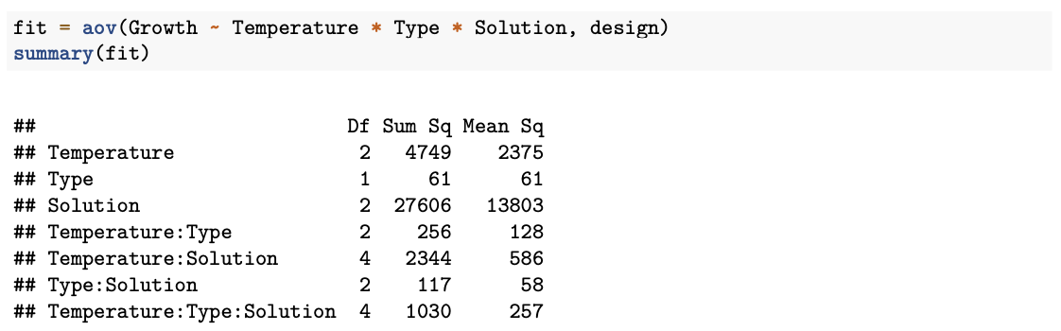
Based on the ANOVA output and examination of mean differences, it can be assumed that only the Temperature, Solution, and possibly the Temperature x Solution have statistically significant effect on water beads growth. Therefore, a reduced model containing only Temperature, Solution, and their interaction was fitted with the updated linear model as follows:
$$Y_{ijkl}= μ+ α_{i}+γ_{k}{+ {αγ}_{ik}+ ε}_{ijkl}$$
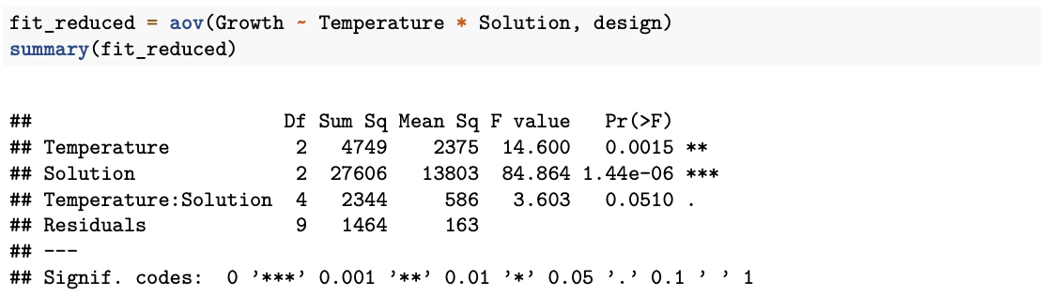
The reduced model identified statistically significant main effects of Temperature (p < 0.01) and Solution (p < 0.01). The Temperature x Solution interaction was marginally nonsignificant (p = 0.051).
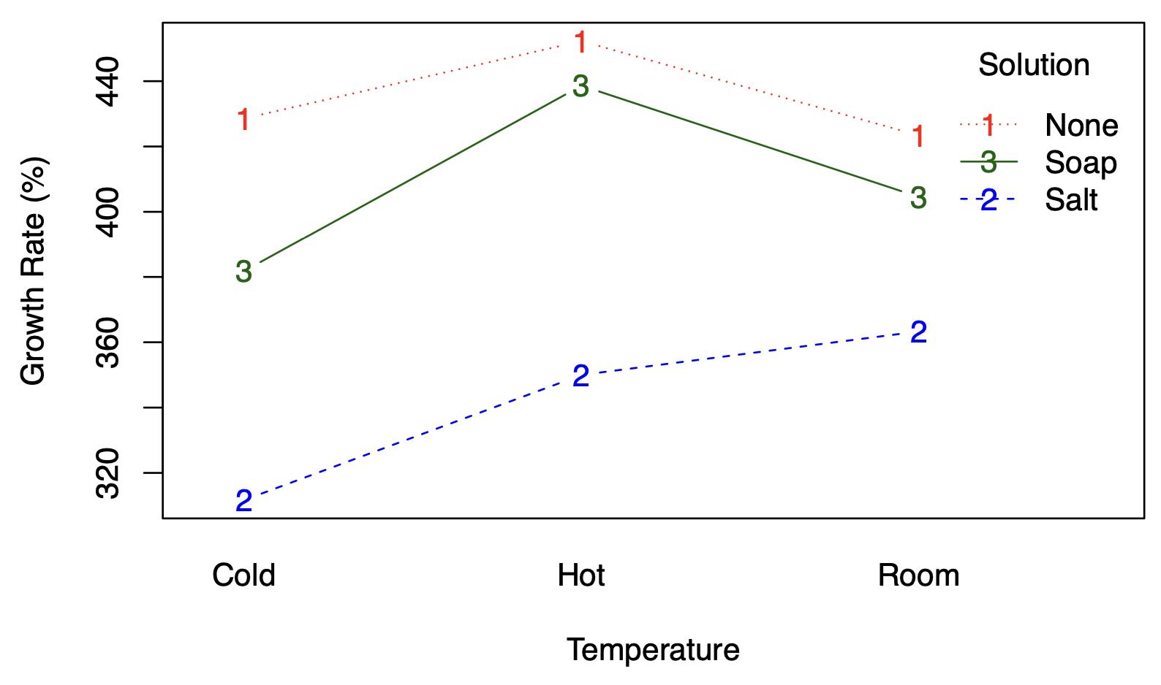
The above interaction plot suggests potential interaction effect between temperature and solution. While decreasing the temperature from Hot to Room reduced the growth rate for the None and Soap solutions but increased it for the Salt solution. To further explore pairwise differences, Tukey’s Honestly Significant Difference (Tukey’s HSD) test was applied:
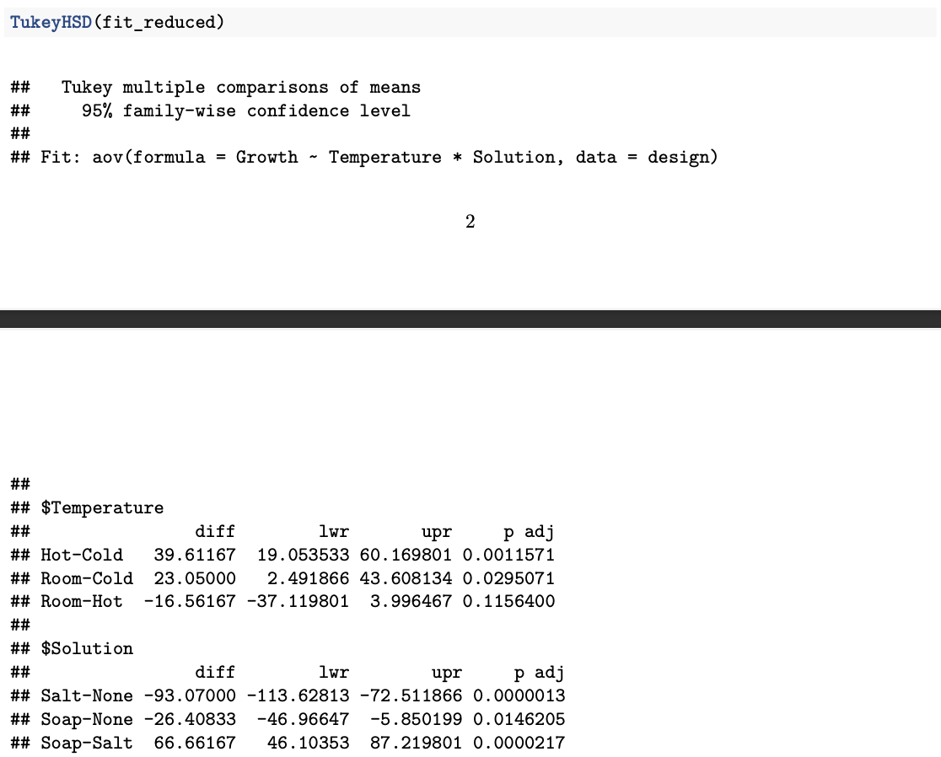
Temperature Effects
Significant positive difference was observed between Hot and Cold (p < 0.01), with Hot showing a 39.6 unit higher mean growth rate. The difference between Room and Cold was also significant (p = 0.03), with Room exceeding Cold by 23.05 units. Although the average growth for Hot was greater than Room, their difference was not statistically significant.
Solution Effects
All three Solution levels differed significantly from one another. The growth for None was significantly greater than Salt (p < 0.01) and Soap (p = 0.015), with mean differences of 93.07 and 26.41 units, respectively. Soap also produced significantly greater growth than Salt (p < 0.01) by 66.66 units. For a full comparison of group means, please see the attached R File.
V. Conclusion
The purpose of the present study was to identify the factors that significantly influence the growth of water beads and to evaluate the accuracy of claims circulated online. Contrary to the statement made by Orbeez, distilled water did not produce greater growth compared to tap water; water type had no statistically meaningful effect on absorption. In contrast, both temperature and solute type demonstrated significant impacts on water beads growth rate. On average, water beads expanded the most in hot water, followed by room temperature water, and least in cold water. However, statistically significant difference was detected only between hot and cold conditions. Water beads showed the greatest growth in pure water, intermediate growth in dish soap water, and the least growth in salt water, with statistically significant difference across all three conditions. While the growth rates for plain and soap water were maximized when the water was hot, followed by room and cold temperature, the growth rate for salt water was the greatest when the water was in room temperature, followed by hot and cold temperature, suggesting potential interaction effect between the two factors. Ultimately, the findings indicate that water beads grow the best in plain water at warm or room temperature, regardless of whether the water is tap or distilled.
Despite these insights, the study has several limitations as mentioned previously. Because baseline diameters of beads were not uniform, initial size differences may have influenced each bead’s capacity for absorption. Additionally, the beads did not receive equal light exposure—beads in the Hot condition were exposed to less light than those in the Room and Cold conditions. Practical constraints and limited materials also required the experiment to be run across different days and times, accounting for potential environmental variability.
Future research could address these limitations by standardizing light exposure and controlling environmental conditions. Additional factors, such as acidity (PH levels), could also be investigated to determine their influence on absorption. Further exploration of temperature through increasing the number of levels may help identify the precise point at which growth begins to stabilize or decline. Finally, given that the Temperature x Solution interaction was close to statistically significant, future studies could examine this relationship in greater depth in a more controlled setting.

Works Cited
“Are Water Beads Dangerous?” Poison Control, National Capital Poison Center, www.poison.org/articles/are-water-beads-toxic.
“How Big Do OrbeezTM Grow? How Can I Make My OrbeezTM Grow Larger?” Orbeez Spin Master Support, Helpshift, 22 Dec. 2020, spinmastersupport.helpshift.com/hc/en/80-orbeez/faq/2365-how-big-do-orbeez-grow-how-can-i-make-my-orbeez-grow-larger/?s=robo-trax&p=web.
“Orbeez: How to Make Them Grow Faster.” Poggers, Poggers, 24 Oct. 2024, poggers.com/blogs/toys/orbeez-how-to-make-them-grow-faster.

